http://www.habitatlogan.org/

https://hshministries.org/home

http://www.jobsforlife.org/

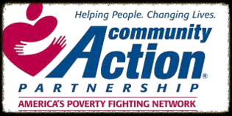

https://www.capcil.info/

http://www.mealsonwheelsamerica.org/

http://pregnancyresourcecenter.org/

http://www.salvationarmyusa.org/
http://www1.salvationarmy.org/uscsvcs.nsf/58473135acc2626286256bb40071f460/97c5d6bd9dfee65e86256f8d005af105!OpenDocument

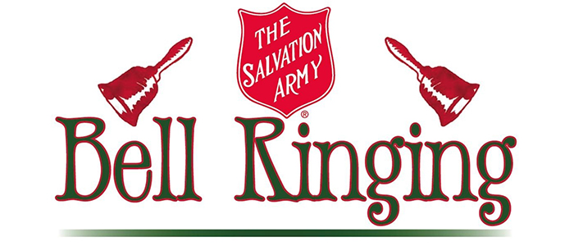

http://www.ringbells.org/

http://lincolncommunitytheatre.org/

Al-Anon
http://www.al-anon.org/

CoDA
http://coda.org/

AA

http://www.aa.org/

